MTH 200 | Calculating Limits graphically

Directions: The goal of the following problems is to help challenge and deepen your understanding of the current topic. Don’t assume that you will know how to answer each and every question. You will work with at least two other students in the class to try and find solutions and write arguments for each of the following questions. Be sure that you question your classmates’ reasoning. If you don’t understand how they are getting something you should ASK THEM TO EXPLAIN! Being able to defend your reasoning is important and so you are actually helping them by asking them to explain.

Challenge Questions
- Consider .
- Set your calculator to a standard 10x10 graphing window. What does the graph of this function suggest the limit would be?
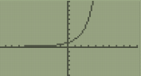
Based on the graph it would appear that .

- Zoom in on the graph near . What does the graph now suggest is the value of the limit?

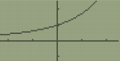
It still appears to be the case that .

- What does the table of function values suggest for the value of the limit?

It still appears to be the case that .

- Do the previous parts confirm that the given limit equals 1?

No. The suggest that the limit might be equal to 1, but we cannot confirm this yet.

If this seems strange and like it should be sufficient justification, consider the following problems.

- Consider .
- Set your calculator to a standard 10x10 graphing window. What does the graph of this function suggest the limit would be?
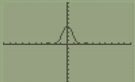
Based on the graph it would appear that

- Zoom in on the graph near . What does the graph now suggest is the value of the limit?
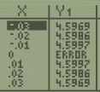
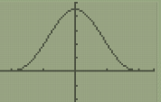
The graph still appears to be confirm that that .

- Use the fact that to evaluate the limit in this question. Hint: multiply the numerator and denominator by .

- Consider . Since we are consider the limit as x decreases without bound, we will want to zoom out and consider larger and larger negative values on the x-axis.
- As you initially begin to zoom out on the graph (values between and 0), what do you believe the value of this limit is? Attempt to adjust your window to have ymin = -1 and ymax = 1.

Standard window Window w/ x between and 0 Window w/ ymin = -1 and ymax = 1
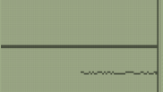
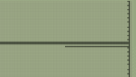
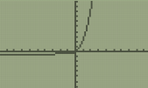

The first and second picture might make us guess that .
The third picture is very confusing and makes guess difficult.

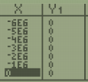
- What is initially suggest by the table of values?

The table seems to suggest that

- What does the graph suggest about the limit when you consider values in the range to ? What does the table of values suggest?

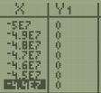
Nothing can really be seen on the graph. Perhaps this might indicate that the function has “merged” into the x-axis. This and the table might lead us to believe that .

- Algebraically determine the correct value of the limit. Hint: consider multiplying by a “fancy 1”.

We see that since , then we can assume that and thus . Therefore,

- Based on the above problems, explain why we should be cautious when using technology to evaluate limits.

Sometimes what we see is the graph isn’t correct. For limits we need to see the behavior of the function as x gets closer and closer and closer to the point of the limit. When looking at the graph we can only see it in a limited situation which could be misleading.

- Based on your above observations, explain why we need to develop mathematical techniques to evaluate limits.

By using technology, we can only guess what the answer should be, but to confirm the guess we need to come up with arguments. Sometimes our guesses can be wrong as seen in some of the previous problems.

